*** 2022 NCCC Convention Shirt Order Form ***
Name: |  |  |  |  |  | Phone: |  | Mail form to:  Michele Cantelmo
Address: |  |  |  |  | Email: |  |  | 235 Clove Road | Montague, NJ 07827
City: |  |  |  | State: |  | Zip: |  | P 973-293-3296 | mtc62vette@gmail.com
Delivery | ___ Ship to address above |  |  |  |  |  |  | MAKE CHECK PAYABLE TO: | East Region NCCC
Method | ___ Pick up at NCCC St. Louis Governors' Mtg OR other location
(Select One) |  |  |  |  |  |  | QTY | PRICE EACH | TOTAL
HATS/CAPS | Port Authority Brush Twill Cap Charcoal |  |  |  |  |  |  | $16
Men’s Ultra Club 8425 Sport Performance Polo 4 oz. 100% micro polyester;
Moisture-wicking; Pill & Snag resistant; UPF 30 protection.
RED WHITE BLUE
Medium |  |  |  |  |  |  |  | $30
Large |  |  |  |  |  |  |  | $30
Xlarge |  |  |  |  |  |  |  | $30
2Xlarge |  |  |  |  |  |  |  | $32
3XLarge |  |  |  |  |  |  |  | $33
Ladies Ultra Club 8425L Sport Performance Polo 4 oz. 100% micro polyester, Moisture-wicking; Pill & Snag resistant; UPF 30 protection
RED WHITE BLUE
Medium |  |  |  |  |  |  |  | $30
Large |  |  |  |  |  |  |  | $30
Xlarge |  |  |  |  |  |  |  | $30
2Xlarge |  |  |  |  |  |  |  | $32
3XLarge |  |  |  |  |  |  |  | $33
Gildan 6 oz. 90%Cotton/10% Polyester T-Shirt
RED BLUE GREY
Medium |  |  |  |  |  |  |  | $19
Large |  |  |  |  |  |  |  | $19
Xlarge |  |  |  |  |  |  |  | $19
2Xlarge |  |  |  |  |  |  |  | $20
3XLarge |  |  |  |  |  |  |  | $21
Date Rec’d  Order: |  |  |  |  | SHIPPING  **$10.00 PER ITEM
Date Mailed/Delivered: |  |  |  |  | TOTAL ORDER
Bank Deposit: |  |  |  |  | **Save on shipping costs by combining club orders!
 |  |  |  |  | 3 to 5 Shirts= $20 |  |  | 6 to 9 Shirts+$25
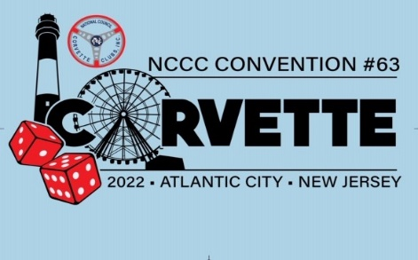 |  |  |  |  |  | Comments:

